Activity 4

The tutorial demonstrated how gradient descent works in practice by plotting the reduction in cost over time. We focused on tuning the learning rate to ensure the model converged efficiently without overshooting the minimum. This hands-on approach provided a clear understanding of how adjusting hyperparameters like learning rate influences training dynamics and model accuracy. It reinforced the importance of finding a balance between speed and stability during optimisation.

50 Iterations and 0.09 Learning rate
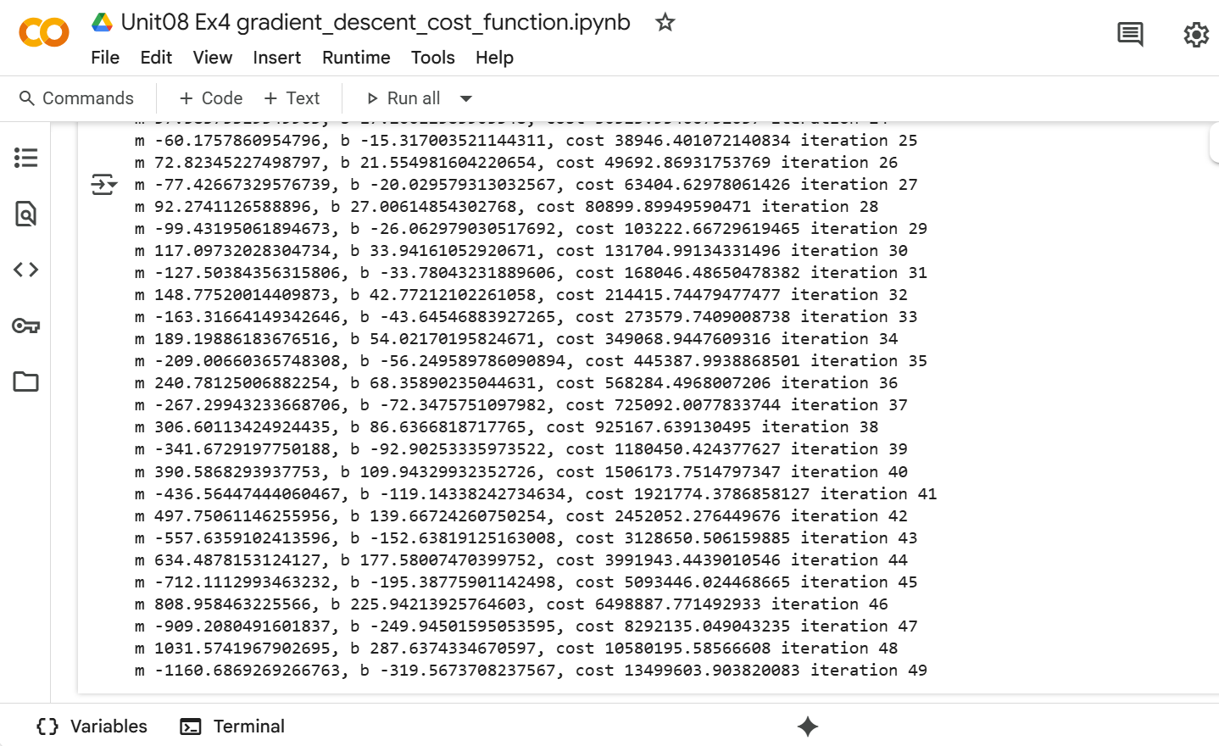

150 Iterations and 0.09 Learning rate
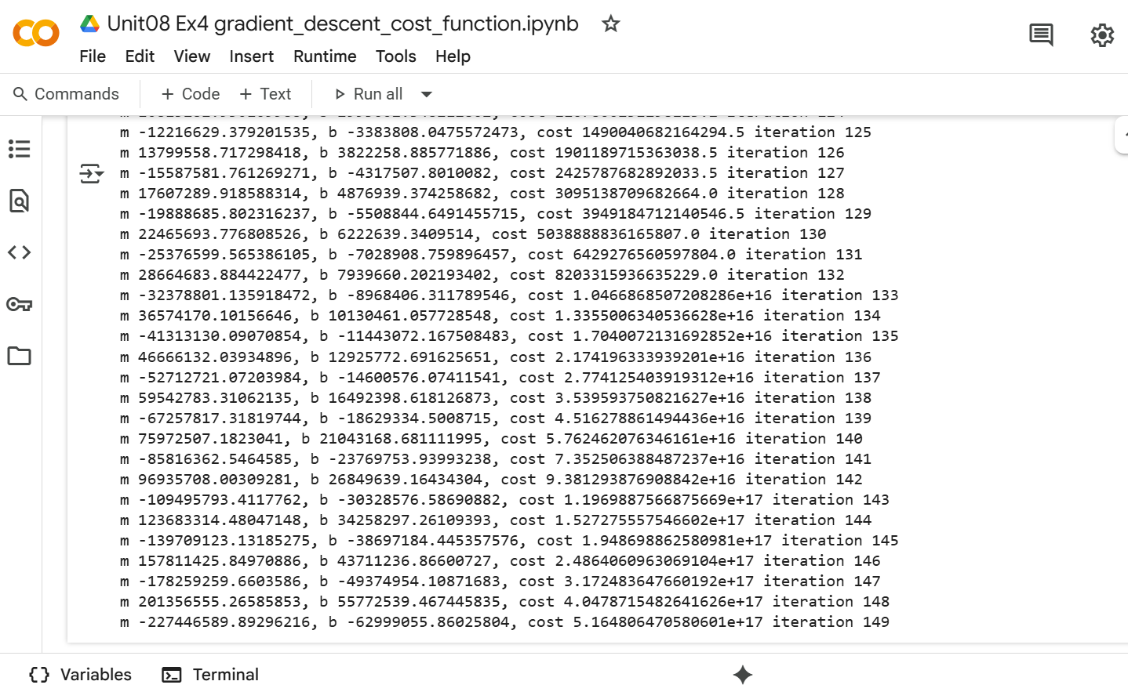

295 Iterations and 0.18 Learning rate
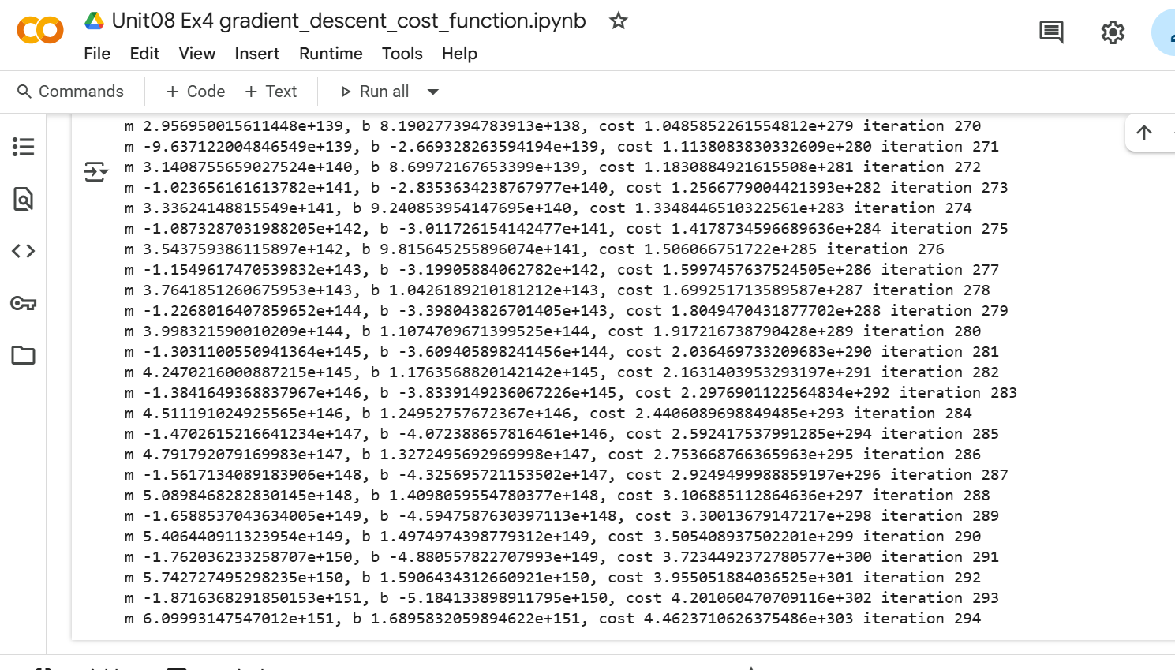

The experiment showed that tuning the learning rate and iteration count requires careful balance. Doubling these values without monitoring the cost trend can lead to overshooting or inefficient training. Conversely, halving them might prevent the model from reaching the optimal minimum. We found that the best approach is to track the decrease in the cost function and extend training only when needed—highlighting the importance of adaptive optimisation based on convergence criteria rather than fixed parameters.

